**停用ipv6**

**[root@px-2 src]# ip addr list**

1: lo: <LOOPBACK,UP,LOWER_UP> mtu 65536 qdisc noqueue state UNKNOWN group default qlen 1000

link/loopback 00:00:00:00:00:00 brd 00:00:00:00:00:00

inet 127.0.0.1/8 scope host lo

valid_lft forever preferred_lft forever

inet6 ::1/128 scope host

valid_lft forever preferred_lft forever

2: ens192: <BROADCAST,MULTICAST,UP,LOWER_UP> mtu 1500 qdisc mq state UP group default qlen 1000

link/ether 00:50:56:ba:40:f3 brd ff:ff:ff:ff:ff:ff

inet 10.4.106.182/21 brd 10.4.111.255 scope global noprefixroute ens192

valid_lft forever preferred_lft forever

inet6 fe80::250:56ff:feba:40f3/64 scope link noprefixroute

valid_lft forever preferred_lft forever

**[root@px-2 src]# sysctl net.ipv6.conf.all.disable_ipv6=1**

net.ipv6.conf.all.disable_ipv6 = 1

You have new mail in /var/spool/mail/root

**[root@px-2 src]# vim /etc/sysctl.conf**

**net.ipv6.conf.all.disable_ipv6=1**

**net.ipv6.conf.default.disable_ipv6=1**

**net.ipv6.conf.lo.disable_ipv6=1**

**2、配置主机名及域名解析**

**[root@px-2 src]# hostnamectl set-hostname oracle-12c**

**[root@px-2 src]# vim /etc/hosts**

**[root@px-2 src]# hostname**

oracle-12c

**[root@px-2 src]# hostnamectl**

Static hostname: oracle-12c

Icon name: computer-vm

Chassis: vm

Machine ID: cf04deaed3da42d4a40e4d1dbdc6c161

Boot ID: 3c987a7fe9a6400bbbf0e8f1d0b4de30

Virtualization: vmware

Operating System: CentOS Linux 7 (Core)

CPE OS Name: cpe:/o:centos:centos:7

Kernel: Linux 3.10.0-1062.el7.x86_64

Architecture: x86-64

**[root@px-2 src]# ping oracle-12c**

PING px-2.hostname.com (10.4.106.182) 56(84) bytes of data.

64 bytes from px-2.hostname.com (10.4.106.182): icmp_seq=1 ttl=64 time=0.017 ms

64 bytes from px-2.hostname.com (10.4.106.182): icmp_seq=2 ttl=64 time=0.021 ms

64 bytes from px-2.hostname.com (10.4.106.182): icmp_seq=3 ttl=64 time=0.023 ms

64 bytes from px-2.hostname.com (10.4.106.182): icmp_seq=4 ttl=64 time=0.021 ms

**中文支持**

**[root@px-2 src]# locale**

LANG=en_US.UTF-8

LC_CTYPE="en_US.UTF-8"

LC_NUMERIC="en_US.UTF-8"

LC_TIME="en_US.UTF-8"

LC_COLLATE="en_US.UTF-8"

LC_MONETARY="en_US.UTF-8"

LC_MESSAGES="en_US.UTF-8"

LC_PAPER="en_US.UTF-8"

LC_NAME="en_US.UTF-8"

LC_ADDRESS="en_US.UTF-8"

LC_TELEPHONE="en_US.UTF-8"

LC_MEASUREMENT="en_US.UTF-8"

LC_IDENTIFICATION="en_US.UTF-8"

LC_ALL=

**[root@px-2 src]# locale -a | grep zh**

zh_CN

zh_CN.gb18030

zh_CN.gb2312

zh_CN.gbk

zh_CN.utf8

zh_HK

zh_HK.big5hkscs

zh_HK.utf8

zh_SG

zh_SG.gb2312

zh_SG.gbk

zh_SG.utf8

zh_TW

zh_TW.big5

zh_TW.euctw

zh_TW.utf8

**[root@px-2 src]# vim /etc/locale.conf**

#LANG="en_US.UTF-8"

LANG=zh_CN.utf8

**[root@px-2 src]# localectl set-locale LANG=zh_CN.utf8**

**[root@px-2 src]# echo $LANG**

en_US.UTF-8

**[root@px-2 src]# reboot**

Connection closing...Socket close.

Connection closed by foreign host.

Disconnected from remote host(10.4.106.182:22) at 17:42:39.

Type `help' to learn how to use Xshell prompt.

[\\vdinas.aishu.cn\vdinas\vdhome\Ariel.xiang\My Documents\NetSarang Computer\7\Xshell\Sessions]$

Connecting to 10.4.106.182:22...

Connection established.

To escape to local shell, press 'Ctrl+Alt+]'.

WARNING! The remote SSH server rejected X11 forwarding request.

Last login: Mon Aug 16 17:15:44 2021 from 10.4.33.152

**[root@oracle-12c ~]#**

**[root@oracle-12c ~]# echo $LANG**

zh_CN.utf8

**安装X服务以及GNOME 界面服务**

**[root@oracle-12c ~]# yum groupinstall "GNOME Desktop" "Graphical Administration Tools"**

**创建oracle数据库需要的用户名和组**

**[root@oracle-12c ~]# groupadd dba**

**[root@oracle-12c ~]# groupadd oinstall**

**[root@oracle-12c ~]# useradd -g oinstall -G dba oracle**

**[root@oracle-12c ~]# passwd oracle**

**QAZxsw!@987**

**[root@oracle-12c ~]# id oracle**

uid=1001(oracle) gid=1001(oinstall) 组=1001(oinstall),1000(dba)

**配置oracle系统使用资源**

**[root@oracle-12c ~]# vim /etc/security/limits.conf**

oracle soft nofile 1024

oracle hard nofile 65536

oracle soft nproc 2047

oracle hard nproc 16384

oracle soft stack 10240

oracle hard stack 10240

**创建安装oracle数据库安装需要的目录**

**[root@oracle-12c ~]# mkdir -p /u01/app/oracle**

**目录oracle用户所有**

**[root@oracle-12c ~]# chown -R oracle.oinstall /u01/**

**[root@oracle-12c ~]# chown -R 755 /u01/**

**[root@oracle-12c ~]# ls -ld /u01/**

drwxr-xr-x 3 755 oinstall 17 8月 16 18:04 /u01/

**安装配置vnc，oralce图形远程桌面**

**[root@oracle-12c ~]# yum install tigervnc-server**

**[root@oracle-12c systemd]# cp /usr/lib/systemd/system/vncserver@.service /etc/systemd/system/vncserver-oracle@.service**

**[root@oracle-12c systemd]# vim** [**/etc/systemd/system/vncserver-oracle@.service**](mailto:/etc/systemd/system/vncserver-oracle@.service)

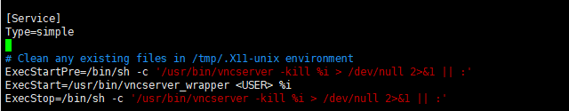

**# Clean any existing files in /tmp/.X11-unix environment**

ExecStartPre=/bin/sh -c ’usr/bin/vncserver -kill %i > /dev/null 2>&1 ||:’

ExecStart=/usr/bin/vncserver %i

ExecStop=/bin/sh -c ’/usr/bin/vncserver -kill %i > /dev/null 2>&1 ||:’

PIDFile=/home/oracle/.vnc/%H%i.pid

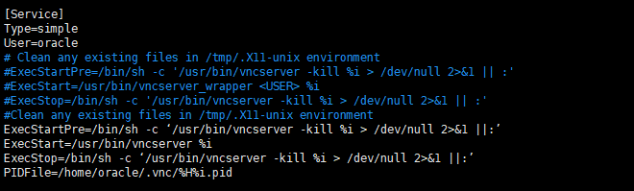

**[root@oracle-12c systemd]# su - oracle**

**[oracle@oracle-12c ~]$ vncpasswd**

Password:QAZxsw!@987

Verify:

Would you like to enter a view-only password (y/n)? n

A view-only password is not used

**[oracle@oracle-12c ~]$exit**

**启动vnc**

**[root@oracle-12c systemd]# systemctl daemon-reload**

**[root@oracle-12c systemd]# systemctl start** [**vncserver-oracle@:1.service**](mailto:vncserver-oracle@:1.service)

**开机自动启动，可以不启动**

**[root@oracle-12c systemd]# systemctl enable** [**vncserver-oracle@:1.service**](mailto:vncserver-oracle@:1.service)

**[root@oracle-12c systemd]# systemctl status** [**vncserver-oracle@:1.service**](mailto:vncserver-oracle@:1.service)

**启动chronyd服务**

**[root@oracle-12c systemd]# systemctl enable chronyd.service**

**[root@oracle-12c systemd]# systemctl start chronyd.service**

**[root@oracle-12c systemd]# systemctl status chronyd.service**

● chronyd.service - NTP client/server

Loaded: loaded (/usr/lib/systemd/system/chronyd.service; enabled; vendor preset: enabled)

Active: active (running) since 一 2021-08-16 17:43:02 CST; 2h 52min ago

Docs: man:chronyd(8)

man:chrony.conf(5)

CGroup: /system.slice/chronyd.service

└─910 /usr/sbin/chronyd

8月 16 17:43:02 oracle-12c systemd[1]: Starting NTP client/server...

8月 16 17:43:02 oracle-12c chronyd[910]: chronyd version 3.4 starting (+CMDMON +N...G)

8月 16 17:43:02 oracle-12c chronyd[910]: Frequency -103.489 +/- 0.083 ppm read fr...ft

8月 16 17:43:02 oracle-12c systemd[1]: Permission denied while opening PID file o...id

8月 16 17:43:02 oracle-12c systemd[1]: Started NTP client/server.

8月 16 17:45:29 oracle-12c chronyd[910]: Source 193.182.111.14 replaced with 139....51

8月 16 18:19:55 oracle-12c chronyd[910]: Source 84.16.67.12 replaced with 193.182...43

8月 16 18:54:29 oracle-12c chronyd[910]: Source 202.112.31.197 replaced with 202....30

8月 16 19:29:15 oracle-12c chronyd[910]: Source 119.28.183.184 replaced with 120....20

8月 16 20:07:26 oracle-12c chronyd[910]: Source 139.199.215.251 replaced with 119...84

Hint: Some lines were ellipsized, use -l to show in full.

**下载vnc view ，安装**

**输入linux地址:**

**输入vnc密码**

**安装oracle**

**解压oracle 12c安装包**

**Unzip**

**[root@oracle-12c database]# yum install compat-libcap1 compat-libstdc++-33 libstdc++-devel gcc gcc-c++ kshlibaio-devel**

**[root@oracle-12c database]# cd /tmp/oracle12c/database/**

**[oracle@oracle-12c oracle12c]$ cd database/**

**[oracle@oracle-12c database]$ id**

**uid=1001(oracle) gid=1001(oinstall) \u7ec4=1001(oinstall),1000(dba)**

**[oracle@oracle-12c database]$ ls**

**install response rpm runInstaller sshsetup stage welcome.html**

**[oracle@oracle-12c database]$ ./runInstaller**

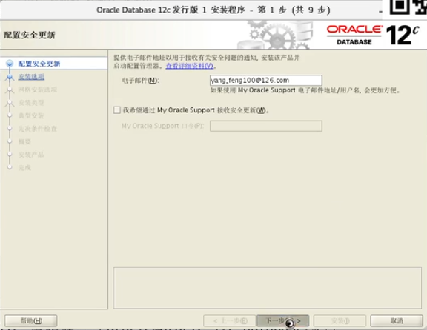

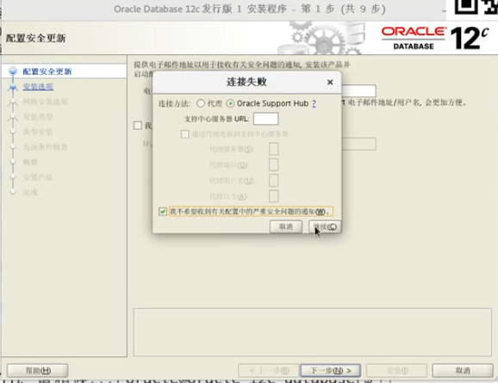

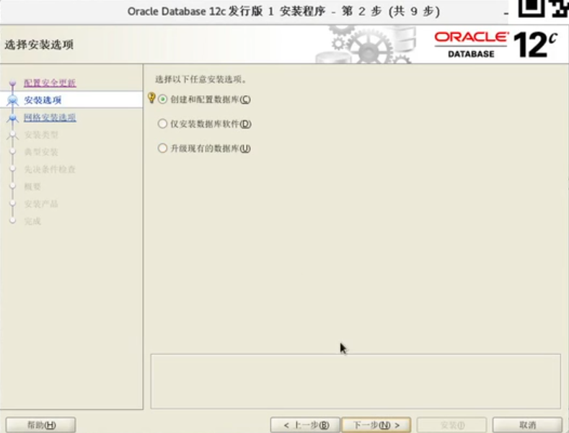

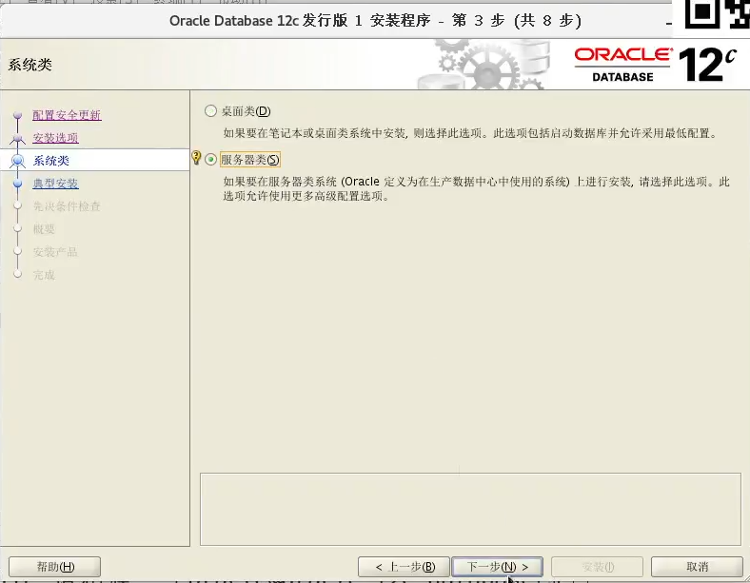

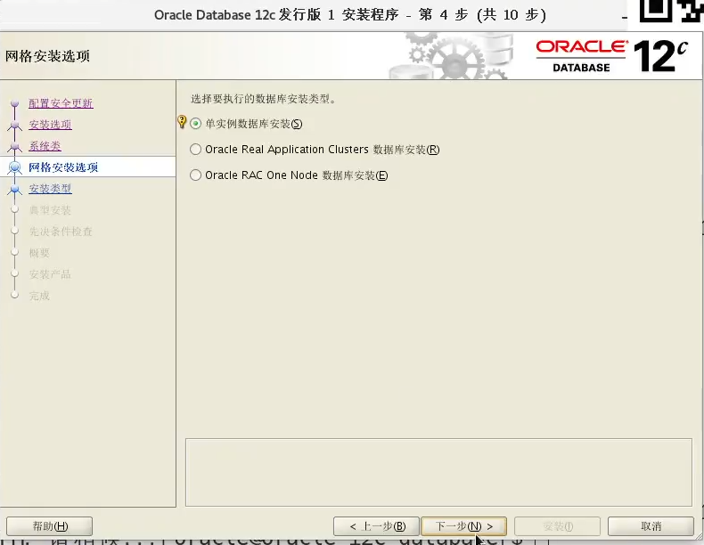

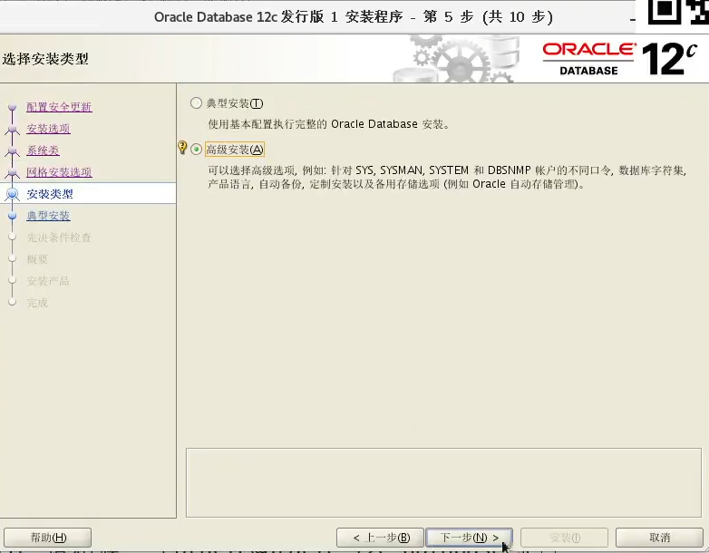

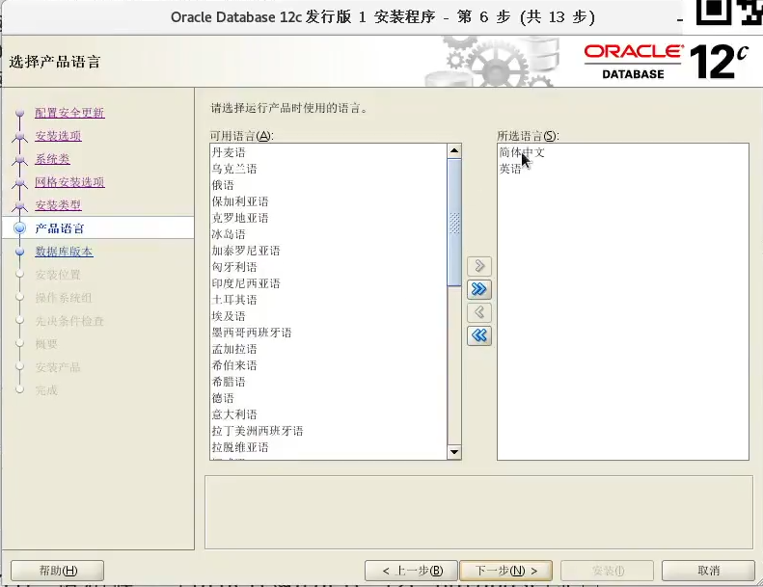

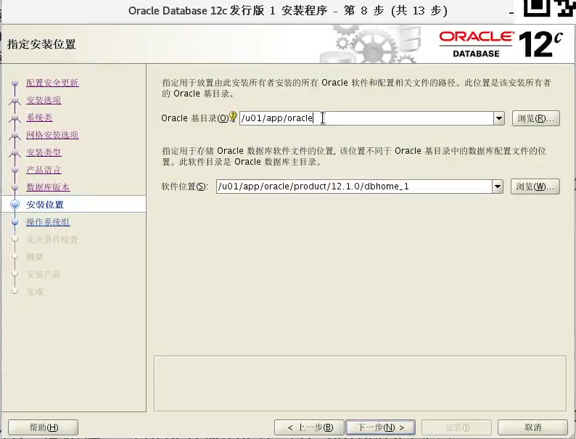

**/u01/app/oracle**

**[root@oracle-12c ~]# chown -R oracle:oinstall /u01**

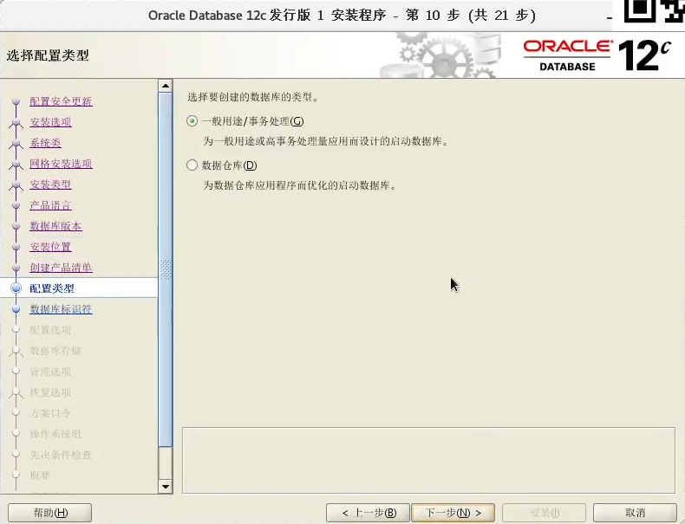

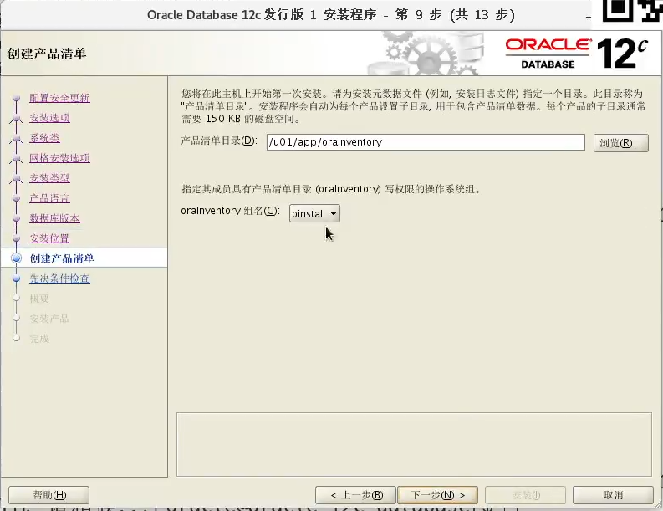

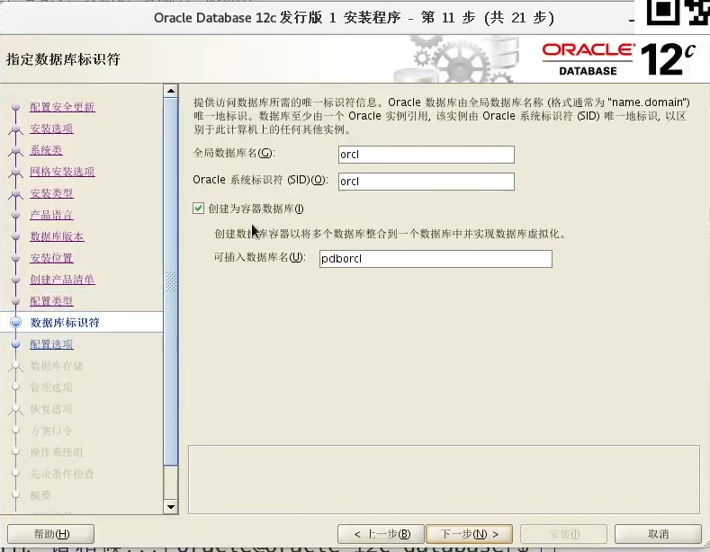

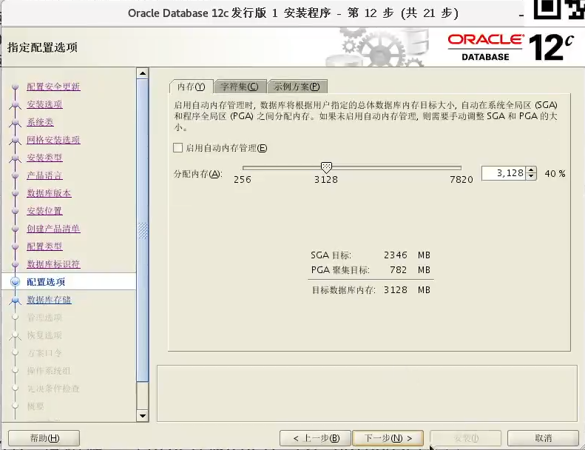

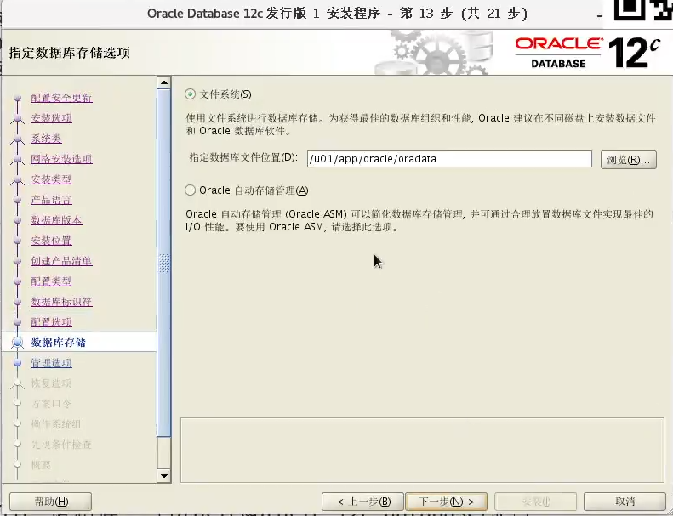

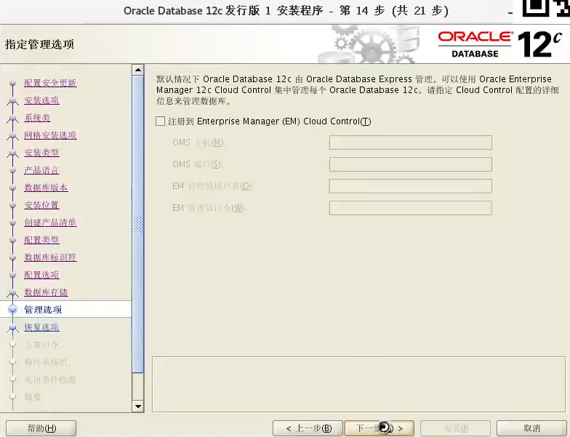

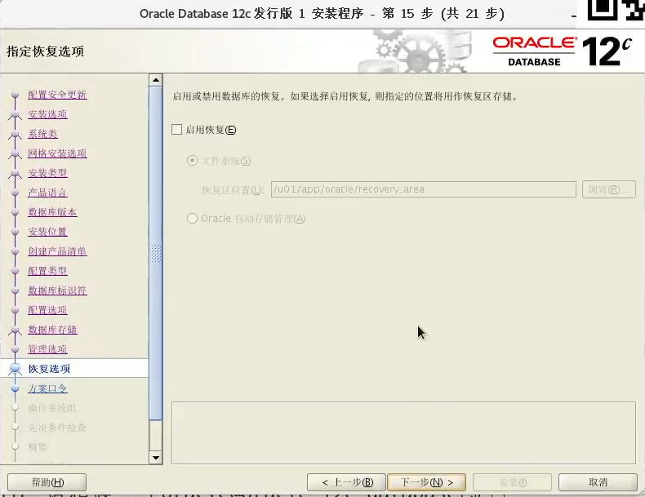

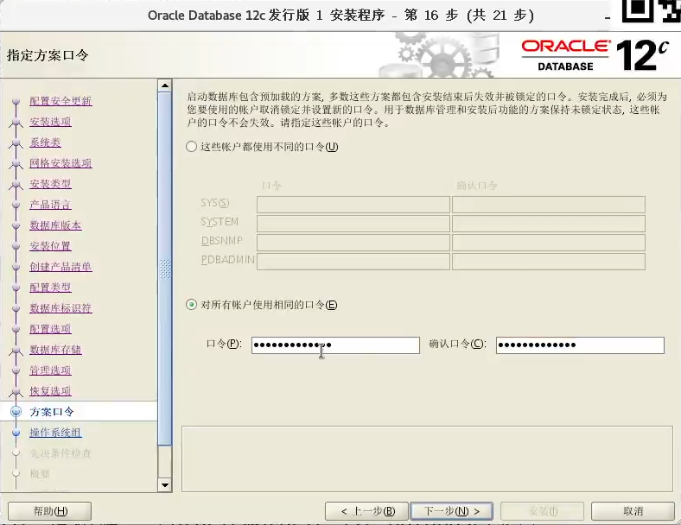

**123qweASD**

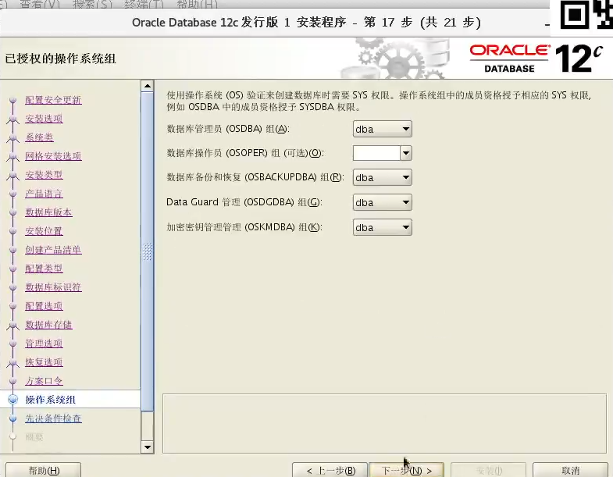

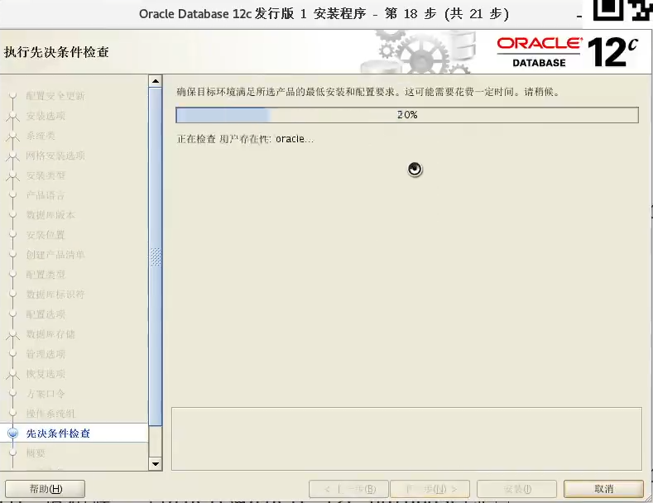

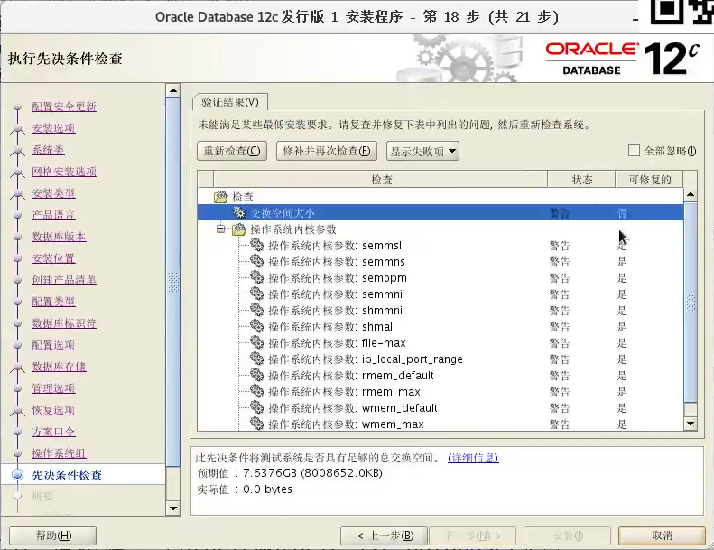

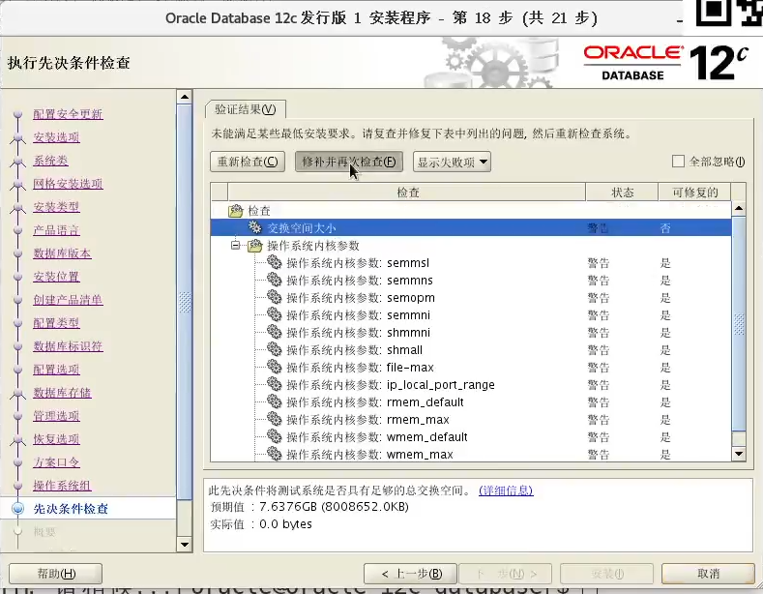

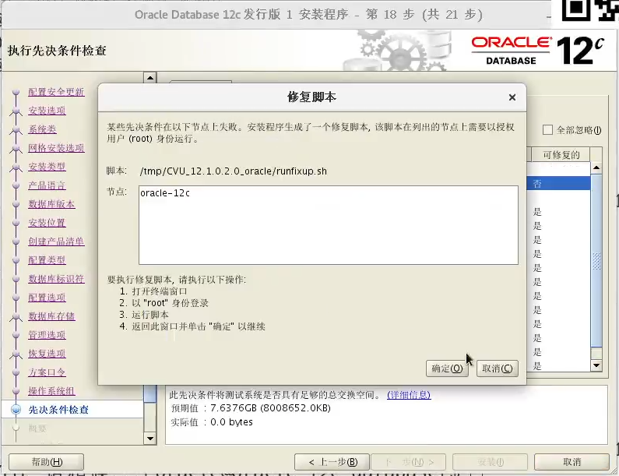

**[root@oracle-12c ~]# /tmp/CVU_12.1.0.2.0_oracle/runfixup.sh**

**All Fix-up operations were completed successfully.**

**[root@oracle-12c ~]#**

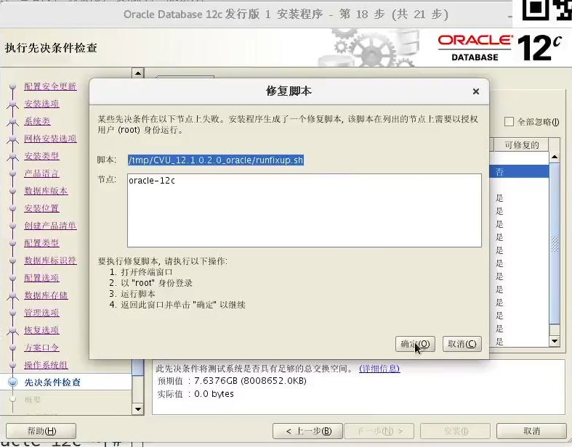

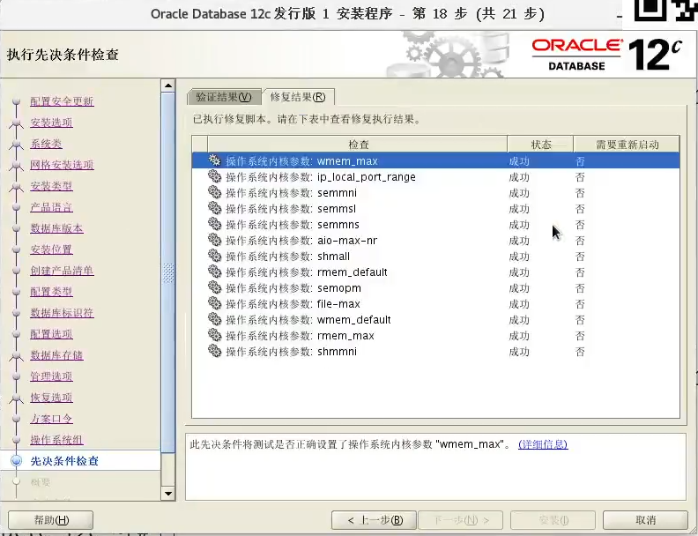

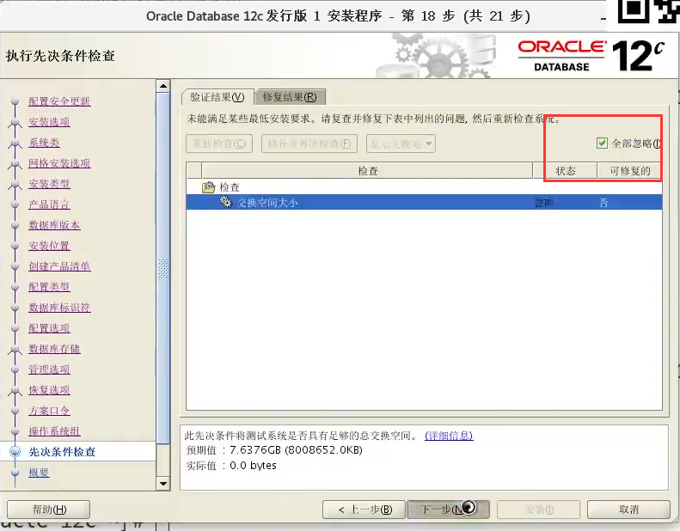

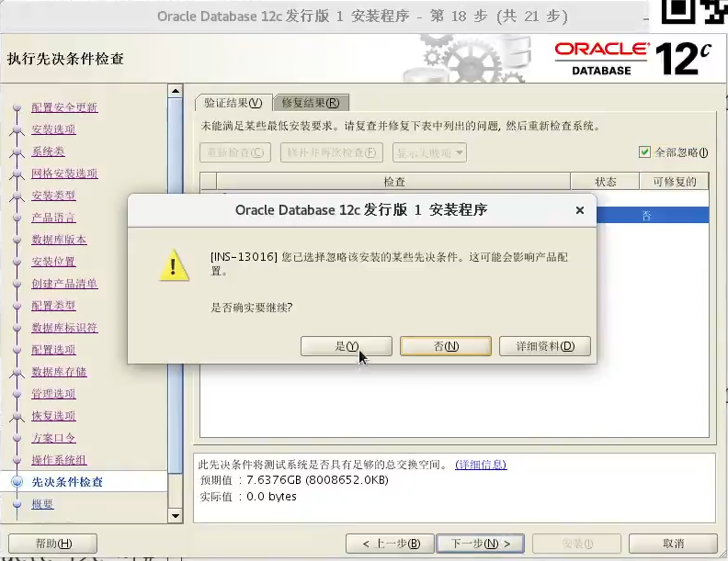

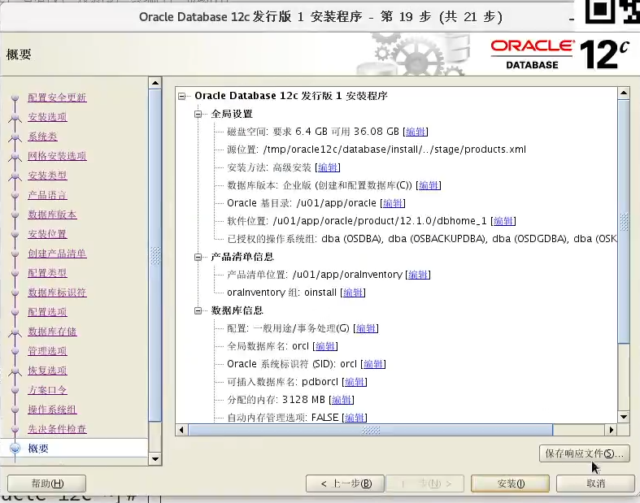

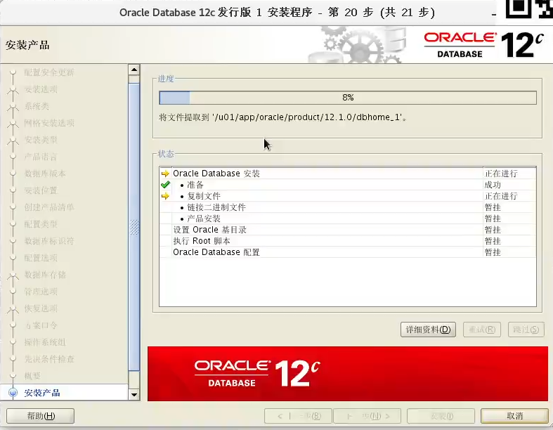

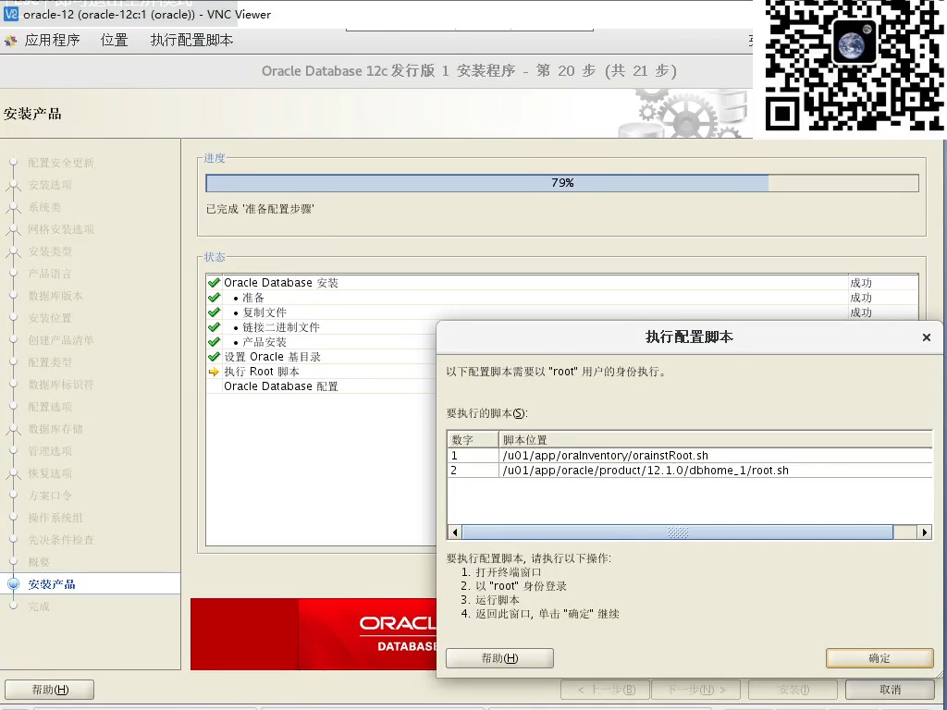

**[root@oracle-12c ~]# /u01/app/oraInventory/orainstRoot.sh**

更改权限/u01/app/oraInventory.

添加组的读取和写入权限。

删除全局的读取, 写入和执行权限。

更改组名/u01/app/oraInventory 到 oinstall.

脚本的执行已完成**。**

**[root@oracle-12c ~]# /u01/app/oracle/product/12.1.0/dbhome_1/root.sh**

Performing root user operation.

The following environment variables are set as:

ORACLE_OWNER= oracle

ORACLE_HOME= /u01/app/oracle/product/12.1.0/dbhome_1

Enter the full pathname of the local bin directory: [/usr/local/bin]: 【直接回车默认】

Copying dbhome to /usr/local/bin ...

Copying oraenv to /usr/local/bin ...

Copying coraenv to /usr/local/bin ...

Creating /etc/oratab file...

Entries will be added to the /etc/oratab file as needed by

Database Configuration Assistant when a database is created

Finished running generic part of root script.

Now product-specific root actions will be performed.

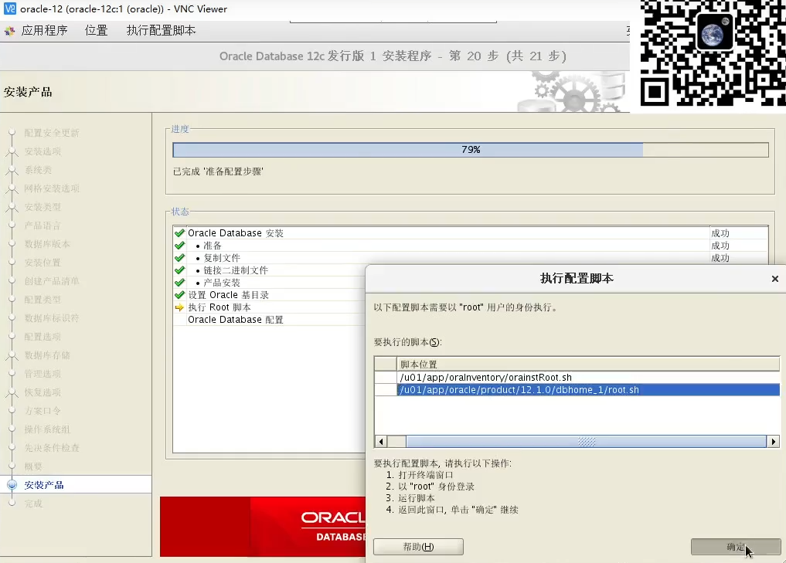

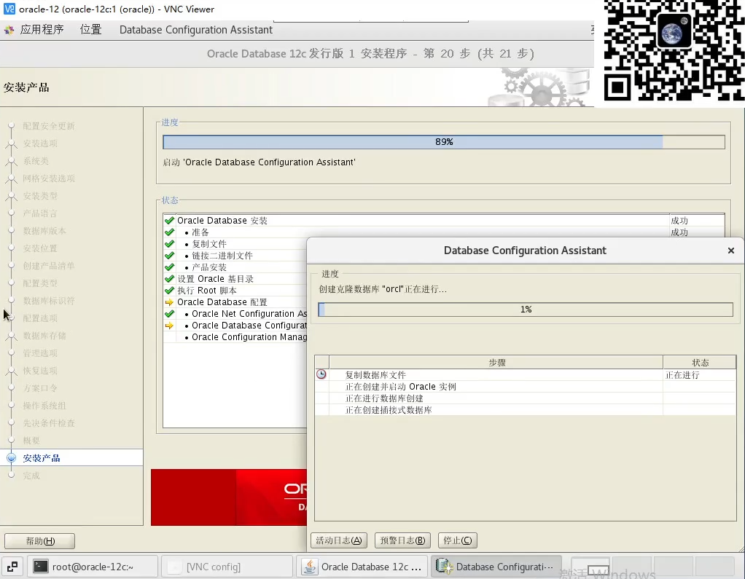

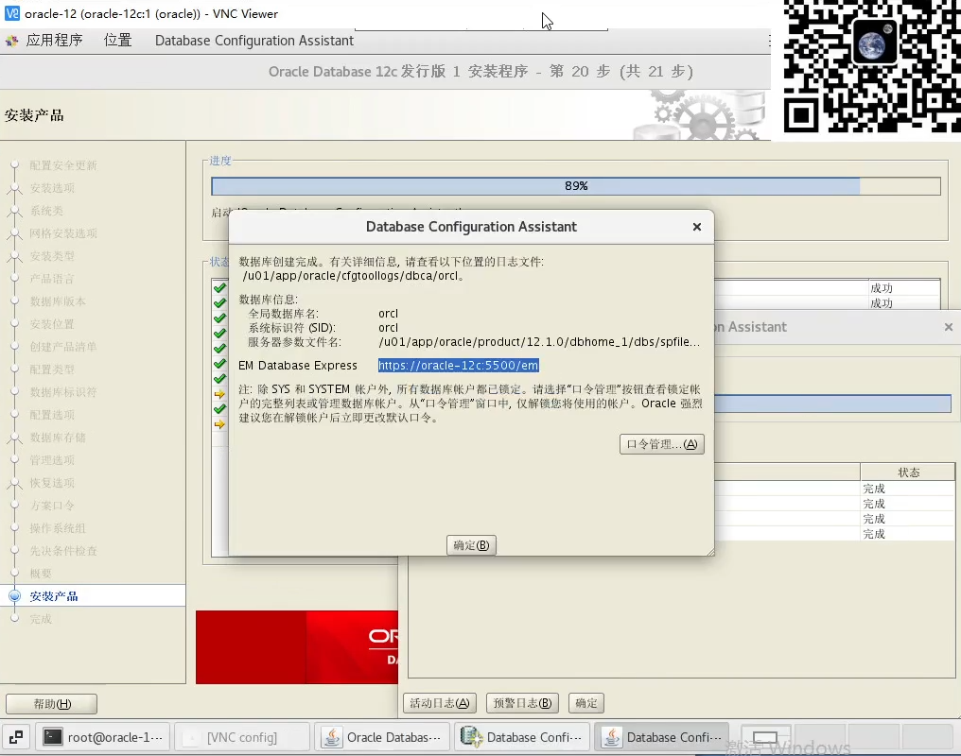

**安装后配置**

**[root@oracle-12c ~]# find /u01 -name listener.ora**

/u01/app/oracle/product/12.1.0/dbhome_1/network/admin/samples/listener.ora

/u01/app/oracle/product/12.1.0/dbhome_1/network/admin/listener.ora

**[root@oracle-12c ~]#**

**cat /u01/app/oracle/product/12.1.0/dbhome_1/network/admin/listener.ora**

# listener.ora Network Configuration File: /u01/app/oracle/product/12.1.0/dbhome_1/network/admin/listener.ora

# Generated by Oracle configuration tools.

LISTENER =

(DESCRIPTION_LIST =

(DESCRIPTION =

(ADDRESS = (PROTOCOL = TCP)(HOST = px-2.hostname.com)(PORT = 1521))

(ADDRESS = (PROTOCOL = IPC)(KEY = EXTPROC1521))

)

)

**[root@oracle-12c ~]#**

**vim /u01/app/oracle/product/12.1.0/dbhome_1/network/admin/listener.ora**

**[root@oracle-12c ~]#**

**cat /u01/app/oracle/product/12.1.0/dbhome_1/network/admin/listener.ora**

# listener.ora Network Configuration File: /u01/app/oracle/product/12.1.0/dbhome_1/network/admin/listener.ora

# Generated by Oracle configuration tools.

LISTENER =

(DESCRIPTION_LIST =

(DESCRIPTION =

(ADDRESS = (PROTOCOL = TCP)(HOST = **oracle-12c**)(PORT = 1521))

(ADDRESS = (PROTOCOL = IPC)(KEY = EXTPROC1521))

)

)

**[root@oracle-12c ~]# find /u01 -name tnsnames.ora**

/u01/app/oracle/product/12.1.0/dbhome_1/network/admin/samples/tnsnames.ora

/u01/app/oracle/product/12.1.0/dbhome_1/network/admin/tnsnames.ora

**[root@oracle-12c ~]#**

**cat /u01/app/oracle/product/12.1.0/dbhome_1/network/admin/tnsnames.ora**

# tnsnames.ora Network Configuration File: /u01/app/oracle/product/12.1.0/dbhome_1/network/admin/tnsnames.ora

# Generated by Oracle configuration tools.

ORCL =

(DESCRIPTION =

(ADDRESS = (PROTOCOL = TCP)(HOST = px-2.hostname.com)(PORT = 1521))

(CONNECT_DATA =

(SERVER = DEDICATED)

(SERVICE_NAME = orcl.hostname.com)

)

)

**[root@oracle-12c ~]#**

**vim /u01/app/oracle/product/12.1.0/dbhome_1/network/admin/tnsnames.ora**

**[root@oracle-12c ~]#**

**cat /u01/app/oracle/product/12.1.0/dbhome_1/network/admin/tnsnames.ora**

# tnsnames.ora Network Configuration File: /u01/app/oracle/product/12.1.0/dbhome_1/network/admin/tnsnames.ora

# Generated by Oracle configuration tools.

ORCL =

(DESCRIPTION =

(ADDRESS = (PROTOCOL = TCP)(HOST = **oracle-12c**)(PORT = 1521))

(CONNECT_DATA =

(SERVER = DEDICATED)

(SERVICE_NAME = **orcl.hostname.com**)

)

)

**监听**

**[root@oracle-12c ~]# netstat -tunlp | grep 1521**

tcp 0 0 0.0.0.0:1521 0.0.0.0:* LISTEN 20757/tnslsnr

**配置安装后随系统启动**

**[root@oracle-12c ~]# vim /etc/oratab**

# This file is used by ORACLE utilities. It is created by root.sh

# and updated by either Database Configuration Assistant while creating

# a database or ASM Configuration Assistant while creating ASM instance.

# A colon, ':', is used as the field terminator. A new line terminates

# the entry. Lines beginning with a pound sign, '#', are comments.

#

# Entries are of the form:

# $ORACLE_SID:$ORACLE_HOME:<N|Y>:

#

# The first and second fields are the system identifier and home

# directory of the database respectively. The third field indicates

# to the dbstart utility that the database should , "Y", or should not,

# "N", be brought up at system boot time.

#

# Multiple entries with the same $ORACLE_SID are not allowed.

#

#

#orcl:/u01/app/oracle/product/12.1.0/dbhome_1:N

orcl:/u01/app/oracle/product/12.1.0/dbhome_1:Y

**配置/etc/rc.local 随系统启动oracle及tnslsnr**

**[root@oracle-12c ~]# vim /etc/rc.local**

#!/bin/bash

# THIS FILE IS ADDED FOR COMPATIBILITY PURPOSES

#

# It is highly advisable to create own systemd services or udev rules

# to run scripts during boot instead of using this file.

#

# In contrast to previous versions due to parallel execution during boot

# this script will NOT be run after all other services.

#

# Please note that you must run 'chmod +x /etc/rc.d/rc.local' to ensure

# that this script will be executed during boot.

touch /var/lock/subsys/local

TMP=/tmp

TMPDIR=

ORACLE_BASE=/u01/app/oracle

ORACLE_HOME=/u01/app/oracle/product/12.1.0/dbhome_1

ORACLE_SID=orcl

ORACLE_TERM=xterm

PATH=/usr/sbin:$PATH

PATH=$ORACLE_HOME/bin:$path

LD_LIBRARY_PATH=$ORACLE_HOME/lib:/lib:/usr/lib

CLASSPATH=$ORACLE_HOME/JRE:$ORACLE_HOME/jlib:$ORACLE_HOME/rdbms/jlib

export CLASSPATHLD_LIBRARY_PATHPATHORACLE_TERMORACLE_SIDORACLE_HOME ORACLE_BASE TMPDIR TMP

su oracle -c "dbstart"

su oracle -c "lsnrctl start"

**配置用户环境变量**

**[root@oracle-12c ~]# vim /etc/profile**

TMP=/tmp

TMPDIR=$TMP

ORACLE_BASE=/u01/app/oracle

ORACLE_HOME=/u01/app/oracle/product/12.1.0/dbhome_1

ORACLE_SID=orcl

ORACLE_TERM=xterm

PATH=/usr/sbin:$PATH

PATH=$ORACLE_HOME/bin:$PATH

LD_LIBRARY_PATH=$ORACLE_HOME/lib:/lib:/usr/lib

CLASSPATH=$ORACLE_HOME/JRE:$ORACLE_HOME/jlib:$ORACLE_HOME/rdbms/jlib

export CLASSPATH LD_LIBRARY_PATH PATH ORACLE_TERM ORACLE_SID ORACLE_HOME ORACLE_BASE TMPDIR TMP

if [ $USER = "oracle" ]; then

if [ $SHELL = "/bin/ksh" ]; then

ulimit -p 16384

ulimit -n 65536

else

ulimit -u 16384-n 65536

fi

fi

【备注:如果不希望所有用户都可以使用sqlplus，可以仅配置oracle用户的~/.bash_profile文

件。】

**重启**

**[root@oracle-12c ~]# reboot**

**[oracle@oracle-12c root]$ sqlplus / as sysdba**

**SQL*Plus: Release 12.1.0.2.0 Production on Tue Aug 17 00:42:40 2021**

**Copyright (c) 1982, 2014, Oracle. All rights reserved.**

**Connected to an idle instance.**

**SQL>**

**问题解决**

**查看tnsnames.ora**

**[oracle@oracle-12c pfile]$**

**cat /u01/app/oracle/product/12.1.0/dbhome_1/network/admin/tnsnames.ora**

**# tnsnames.ora Network Configuration File: /u01/app/oracle/product/12.1.0/dbhome_1/network/admin/tnsnames.ora**

**# Generated by Oracle configuration tools.**

**ORCL =**

**(DESCRIPTION =**

**(ADDRESS = (PROTOCOL = TCP)(HOST = oracle-12c)(PORT = 1521))**

**(CONNECT_DATA =**

**(SERVER = DEDICATED)**

**(SERVICE_NAME = orcl.hostname.com) 改成orcl**

**)**

**)**

**查看监听和启动监听**

**[oracle@oracle-12c root]$ lsnrctl status**

LSNRCTL for Linux: Version 12.1.0.2.0 - Production on 17-AUG-2021 08:57:42

Copyright (c) 1991, 2014, Oracle. All rights reserved.

Connecting to (DESCRIPTION=(ADDRESS=(PROTOCOL=TCP)(HOST=oracle-12c)(PORT=1521)))

STATUS of the LISTENER

------------------------

Alias LISTENER

Version TNSLSNR for Linux: Version 12.1.0.2.0 - Production

Start Date 17-AUG-2021 00:48:54

Uptime 0 days 8 hr. 8 min. 48 sec

Trace Level off

Security ON: Local OS Authentication

SNMP OFF

Listener Parameter File /u01/app/oracle/product/12.1.0/dbhome_1/network/admin/listener.ora

Listener Log File /u01/app/oracle/diag/tnslsnr/oracle-12c/listener/alert/log.xml

Listening Endpoints Summary...

(DESCRIPTION=(ADDRESS=(PROTOCOL=tcp)(HOST=px-2.hostname.com)(PORT=1521)))

(DESCRIPTION=(ADDRESS=(PROTOCOL=ipc)(KEY=EXTPROC1521)))

The listener supports no services

The command completed successfully

**[oracle@oracle-12c root]$ lsnrctl star**

LSNRCTL for Linux: Version 12.1.0.2.0 - Production on 17-AUG-2021 08:58:13

Copyright (c) 1991, 2014, Oracle. All rights reserved.

TNS-01106: Listener using listener name LISTENER has already been started

**切换到oracle用户**

**su oracle**

**sqlplus / as sysdba 超级管理员登录**

**SQL> select status from v$instance;**

select status from v$instance

*

ERROR at line 1:

ORA-01034: ORACLE not available

Process ID: 0

Session ID: 0 Serial number: 0

**SQL> startup**

ORACLE instance started.

Total System Global Area 1593835520 bytes

Fixed Size 2924880 bytes

Variable Size 1023413936 bytes

Database Buffers 553648128 bytes

Redo Buffers 13848576 bytes

Database mounted.

Database opened.

**SQL> select instance_name from gv_$instance;**

INSTANCE_NAME

----------------

Orcl

**[oracle@oracle-12c root]$ sqlplus / as sysdba**

SQL*Plus: Release 12.1.0.2.0 Production on Tue Aug 17 09:16:07 2021

Copyright (c) 1982, 2014, Oracle. All rights reserved.

Connected to:

Oracle Database 12c Enterprise Edition Release 12.1.0.2.0 - 64bit Production

With the Partitioning, OLAP, Advanced Analytics and Real Application Testing options

**SQL> select status from v$instance;**

**STATUS**

**------------**

**OPEN**